k8-cluster deployment commands

- Go into the killercoda site and perform the commands.

- Start with sudo su command to become as a root use

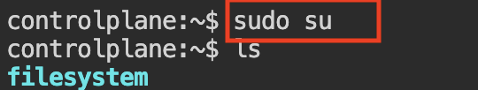

- Then create a namespace t20-as
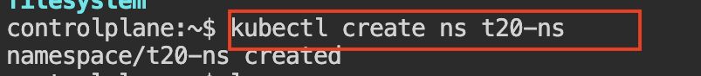
- Cmd: kubectl create ns t20-ns (this cmd is used to create the name-space )

- Then create a directory name it as t20-dep-yaml-files

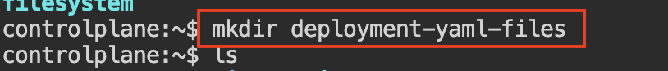
    - Cmd: mkdir t20-dep.yaml (this cmd is used to create a new directory)

- After creating the directory go into the directory
- Then paste the deployment code in the file

apiVersion: apps/v1
kind: Deployment
metadata:
name: ipl-dep
namespace: t20-ns
spec:
replicas: 3
selector:
matchLabels:
app: ipl-app
template:
metadata:
labels:
app: ipl-app
spec:
containers:
- name: ipl-container
image: nginx:latest
ports:
- containerPort: 80

    - Cmd : cd deployment-yaml-files (this cmd is used to enter into the selected directory)
- In that directory create a file name it as t20-dip.yaml

    - Cmd: vi t20-dep.yaml(this cmd is used to enter into the file so that we can add the yaml file in it)
- Now apply the deployment file to run other process

  - Cmd: kubectl apply -f t20-dep.yaml(this cmd is used to run what all the data presented in the yaml file)
- To check all the pods

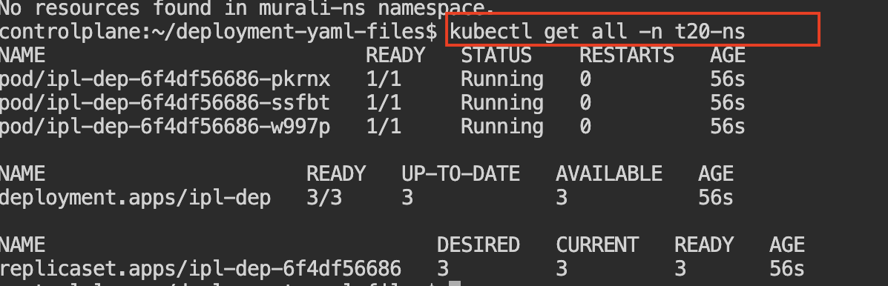
- Cmd: kubectl get all -n t20-ns (this cmd is used to check all the running pods.)
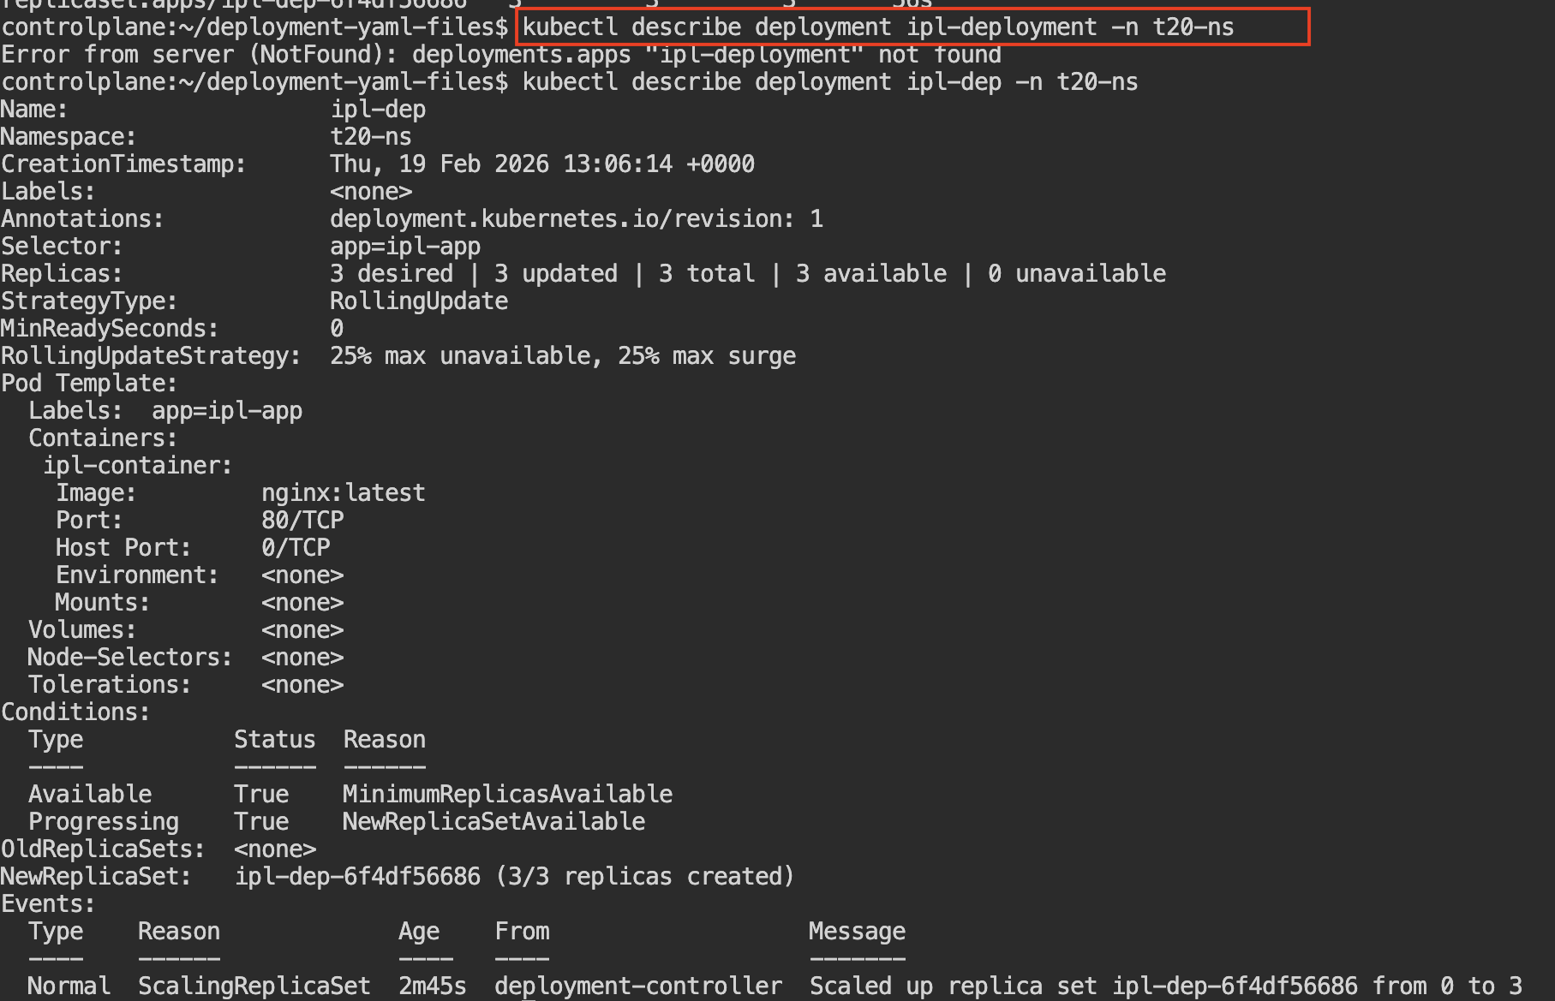
- Now It shows complete details about the deployment.

- Cmd : kubectl describe deployment ipl-deployment -n t20-ns

- After completing the cmd now just copy the pod number and check with the command

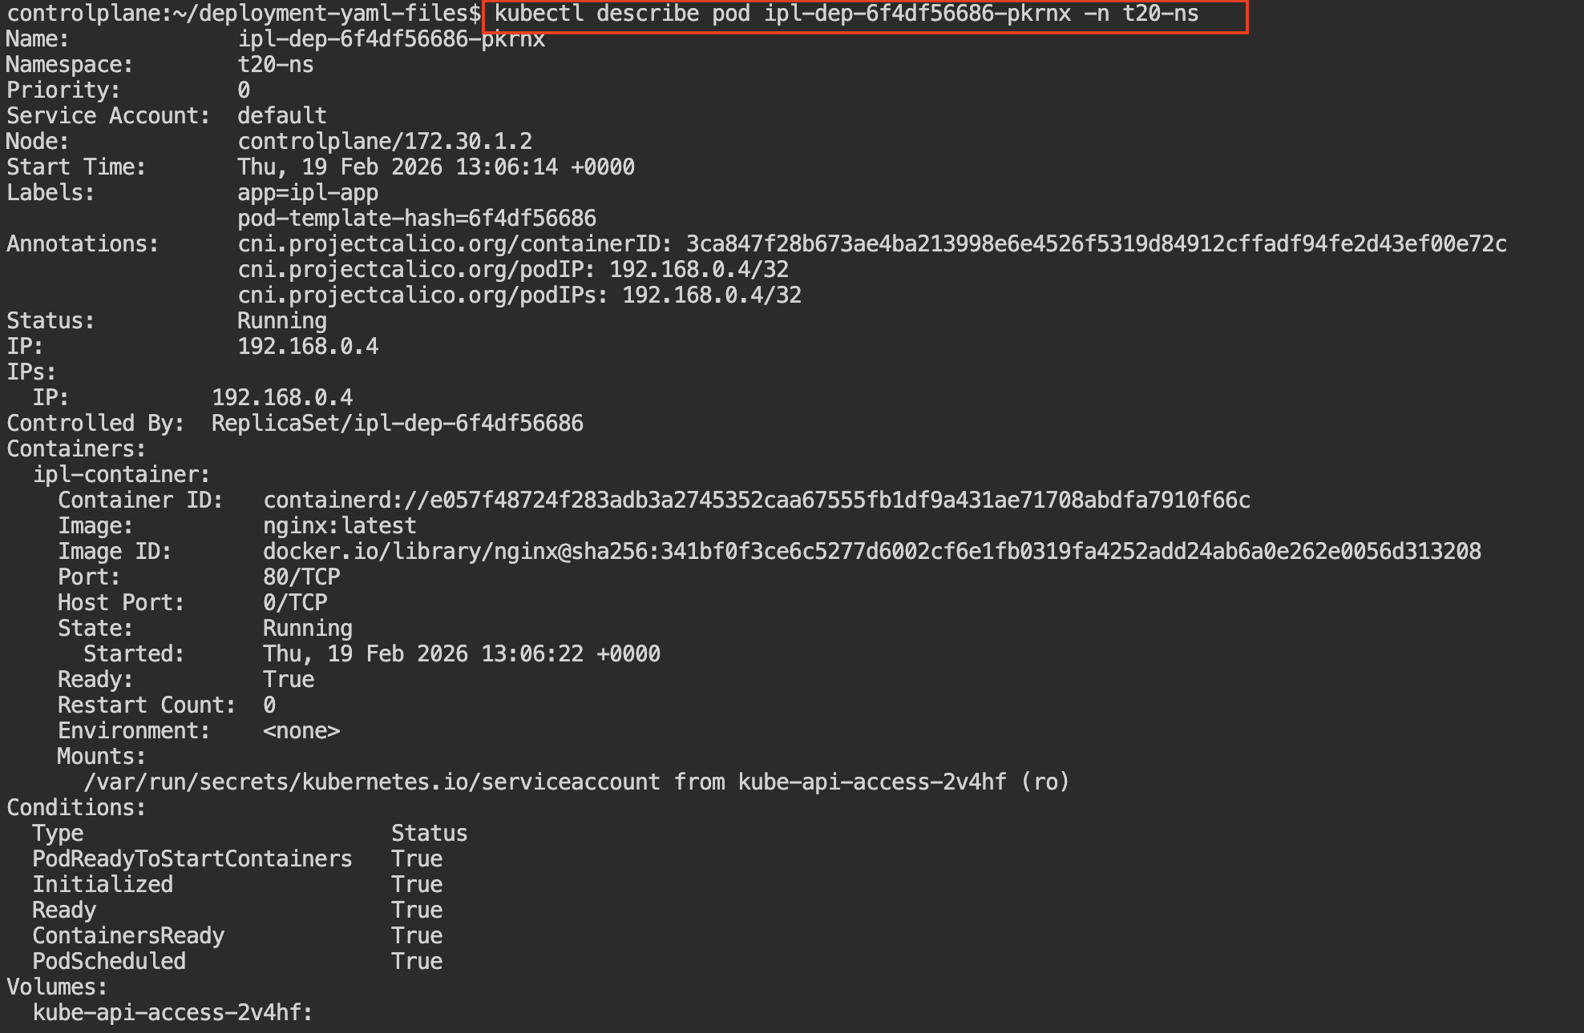
Cmd: kubectl describe pod ipl-dep-6f4df56686-pkrnx -n t20-ns
- It checks and shows the real-time status of the deployment update (whether the rollout is successfully completed or still in progress).

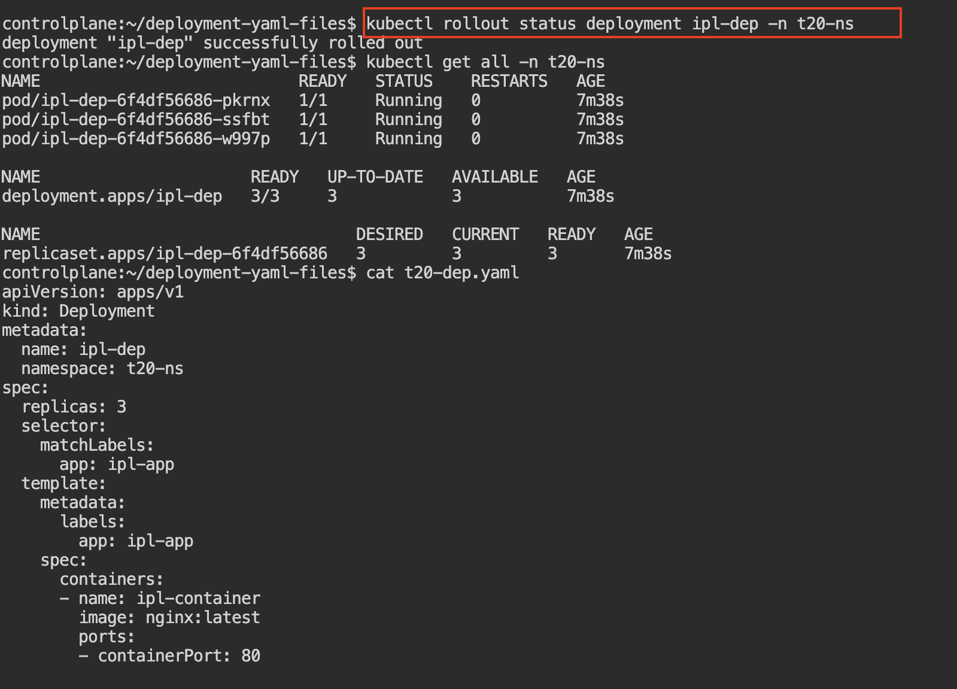
- Cmd: kubectl rollout status deployment ipl-dep -n t20-ns
- 13. It rolls back the deployment to the previous working version if the current update has issues.

- Cmd : kubectl rollout undo deployment ipl-dep -n <namespace>

